

CUSTOMER RETENTION PROJECT

Submitted by:

RAVI PRAKASH BAJPAI

**ACKNOWLEDGMENT**

For this project data was provided by Flip robo team. For this projects I have refered to by video leactures given by data trained. I have also taken help from by mentor Mr shwetank Mishra . I have also reffered to many other websites like kaggle, analyticsvidhya, medium.com and many other.

**INTRODUCTION**

* Business Problem Framing

This project deal with the business related to e commerce platform like amazon ,flipkart and other.

In this project how customer can be retented or how customer can be facilitated so that he may shop again.

* Conceptual Background of the Domain Problem

We must have some knowledge about e-commerce that is how to purchase thing on e commerce platforms.

* Motivation for the Problem Undertaken

This project may be very useful for person doing business through online platforms and also to e commerce business. I have being motivated for this project firstly because I have some idea how these platforms works and secondly many people I know who are doing online business through out the globe so this project may help them to expand their business.

**Analytical Problem Framing**

* Mathematical/ Analytical Modeling of the Problem

In this project many python libraries has been used like pandas, numpy.for visualization process matplot and seaborn has been used. Data set for the given project seems to be in two parts that is numerical features and object type features. these are hedonic values and utilitarian values. Analysis has been done on these values.

* Data Sources and their formats

Data for this project was provided by our team that is flip robo.it was csv file containing nearly 70+ features. Out of which 47 were numeric type and rest were object type.

* Data Preprocessing Done

Data for the project contains 269 rows and 71 columns , Data for the given project was almost cleaned there were no null values nor any values was missing.it contains 47 numeric data type features and rest were in object data type.

Visualizations

Count plot

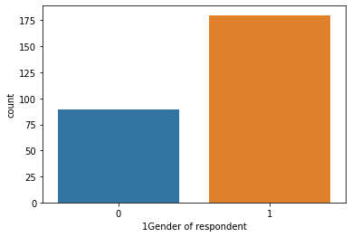

it can be infered that gender of type 1 are shoping more than 0 type gender.

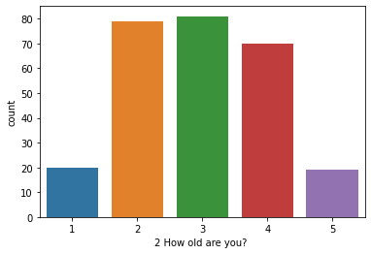

it can be observed from count plot that type 2,3,4 are more in number as compare to 1 and 5.

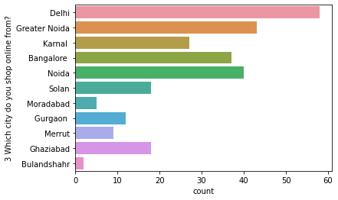

it can be observed that from delhi there are maximum number of customer and from bulandshahr there are very less number of customers.

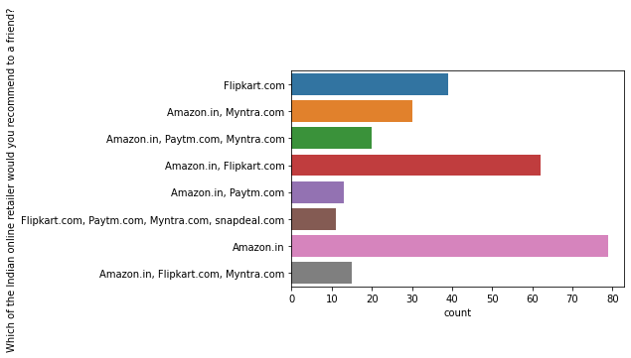

it can seen from graph that alone amazon is covering larger numbers of customers

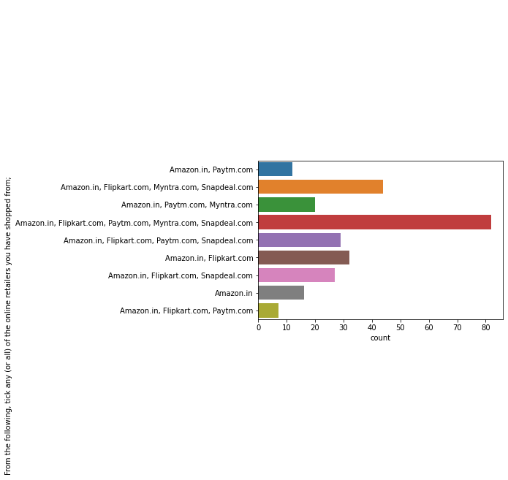Amazon has maximum customers and than flipkart and other.

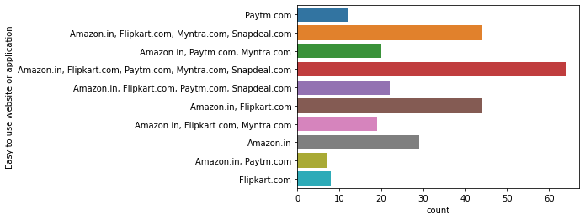

Main priority is given to amazon than flipkart for easy to use application.

HEAT MAP

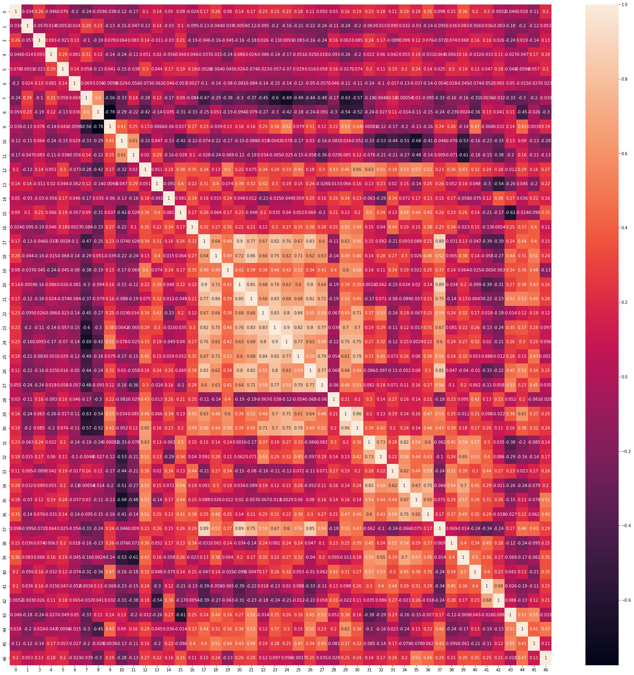

considering .85 and more than .85 values as highly corelated

Now we can see sets of columns are corelated to each other

37 and 17 , 37 and 20 , 37 and 26 , 20 and 17 , 21 and 18 , 21 and 20 , 24 and 23 , 30 and 29

where 37 column name :- User satisfaction cannot exist without trust  
17:-The content on the website must be easy to read and understand  
20:-All relevant information on listed products must be stated clearly  
26:-Empathy (readiness to assist with queries) towards the customers  
21:-Ease of navigation in website  
18:-Information on similar product to the one highlighted is important for product comparison  
24:-Convenient Payment methods  
23:-User friendly Interface of the website  
30:-Enjoyment is derived from shopping online  
29:-Online shopping gives monetary benefit and discounts

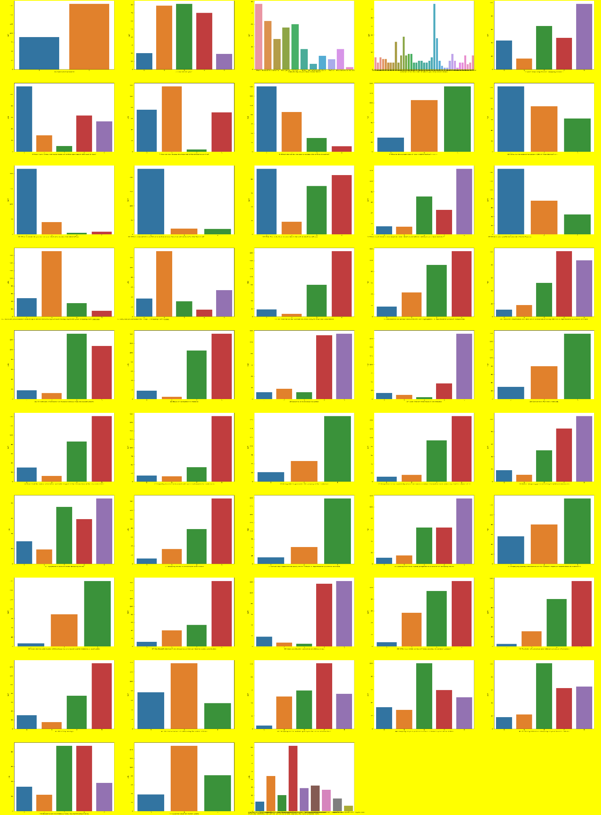

Many other observations can be done in this project by considering individual features by above histogram plot and count plot.

**CONCLUSION**

From the given model it is concluded that for each features analysis can be done. We can make analysis on many other features in such a way that only focusing on particular values of features great improvement can be done. We can also make interpretation which is maximum and which is minimum for any features.